2. Problem Statement

**1.Write a simple program to show inheritance in scala.**

Code

***package*** *firstpackage*

***class*** *Employee{*

***var*** *salary:Float = 10000*

*}*

***class*** *Programmer* ***extends*** *Employee{*

***var*** *bonus:Int = 5000*

*println("Salary = "+salary)*

*println("Bonus = "+bonus)*

*}*

***object*** *MainObject{*

***def*** *main(args:Array[String]){*

***var*** *x =* ***new*** *Programmer()*

*}*

*}*

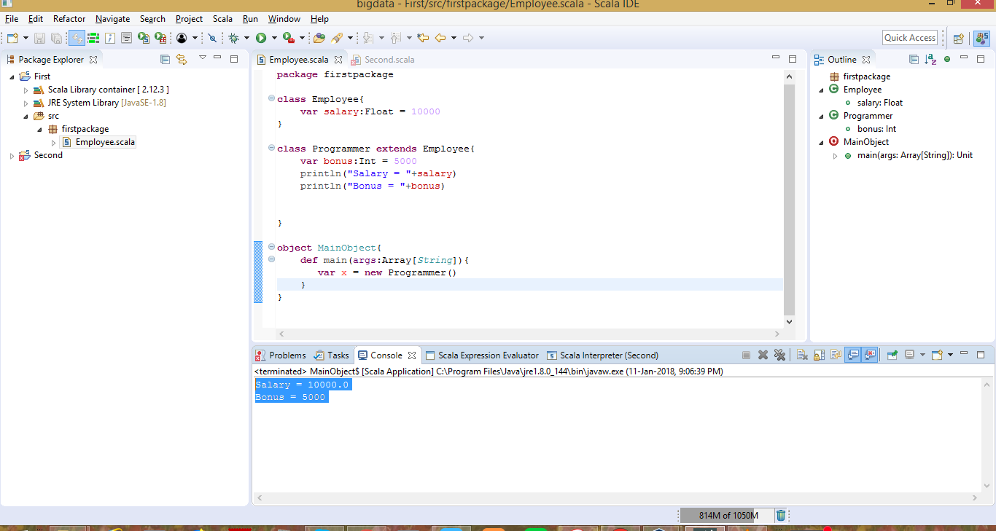

**2.Write a simple program to show multiple inheritance in scala.**

***package*** *firstpackage*

***class*** *Employee2{*

***var*** *salary1 = 10000*

*}*

***class*** *B* ***extends*** *Employee2{*

***var*** *salary2 = 20000*

*}*

***class*** *C* ***extends*** *B{*

***def*** *show(){*

*println("salary1 = "+salary1)*

*println("salary2 = "+salary2)*

*}*

*}*

***object*** *MainObject2{*

***def*** *main(args:Array[String]){*

***var*** *c =* ***new*** *C()*

*c.show()*

*}*

*}*

